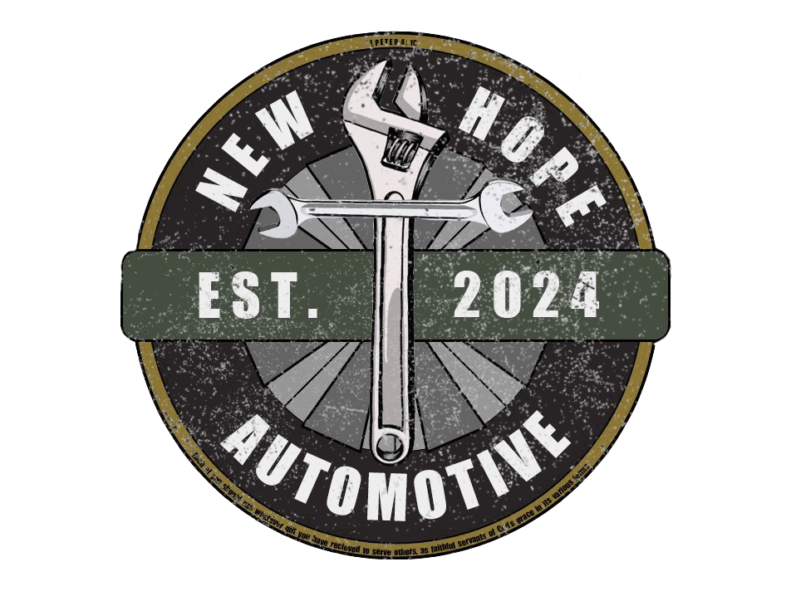
Income Eligibility Verification
_______________________________________________________________

Client Name and Contact Information
Number of Persons in Household
Gross Annual Income*

*Annual Income is based on the most recent 30-day period, projected for the next 12 months. Income sources terminated in the last month do not need to be included in this calculation.

Instructions for Case Manager/Third Party Verifying Income: Note: the client MUST call New Hope Automotive for an appointment. We do not need this form completed until the date of their appointment. We will not call them upon receipt of this form.

This form is to certify that the income received by the above-named individual does not exceed the following income eligibility guidelines for services from New Hope Automotive:
Federal Poverty Guidelines 2024 (150%)
Persons in Household | Annually | Monthly | Weekly
1 | $22,590 | $1,882 | $470
2 | $30,660 | $2,555 | $639
3 | $38,730 | $3,227 | $807
4 | $46,800 | $3,900 | $975
5 | $54,870 | $4,572 | $1143
6 | $62,940 | $5,245 | $1311

Documentation of Client Income: New Hope Automotive expects that third parties completing this form will maintain source documents used to determine income for clients who are planning to be customers at New Hope Automotive (following your agency’s retention policies). We do not require that you submit this documentation, only this signed Certification of Income Eligibility.

I certify that the household of _____________________ is at/below 150% of Federal Poverty Guidelines.

__________________________________ _____________ _________________________
Case Manager / Agency Staff Signature Date Referral Agency Name

RETURN FORM TO: incomeverification@newhopeautomotive.org 734-732-3204 (phone)
855 Aspen Woods Trl, Brighton, MI 48114 WE DO NOT HAVE A FAX

